Mathematics Assignment Unit 7

Godfrey Ouma
University of the People
MATH 1302 - Discrete Mathematics
Saurabh Kumar
March 22, 2024

Math Assignment Unit 7
- In a hostel, there are around ‘n’ number of students (assume a number above 100 for n) with rooms categorized as triple, double, and single occupancy. Explain how you will represent the above data as a graph.
Students’ data based on room occupancy can be represented using a graph where vertices and edges will be assigned as student and how students are connected to each other respectively.
(i) Will the graph be a simple graph or a multigraph?
A simple graph would be suitable for this case. Jamaloodeen et al. (2021) define a simple graph one with neither loop (edges joining the same vertex) nor two edges joining the same pair of vertices. Based on this definition, the simple graph to represent this situation will have only one edge connecting the same pair of students with the consideration that there will be no student allocated the same room as themselves.
(ii) Will it have loops?
Since a simple graph as defined above does not allow students to be allocated the same room as themselves, it therefore implies that the graph will not have loops.
(iii) What is the possible maximum and minimum degree for each student?
The room with three bed capacity will have students connected to at least other students within the same room, thus having a minimum degree of 2. The room with two bed capacity will have students connected to at least one other student they are sharing a room with leading to a minimum degree of 1. Finally, a room with one bed capacity will have only one student not connected to any other student, thus having a minimum degree of 0. Therefore, it is possible to determine the minimum degree for each student. Nevertheless, the maximum degree is difficult to predict because it depends on the number of students, and this can be expressed $n-1$, where n is the total number of students provided none of them is connected to themselves as mentioned earlier. Assuming the total number of rooms is 120, for instance, the maximum degree for each student will be 119.
(iv) If all problems are represented in the form of graphs, won’t the problems be easily visualized and solved?
Although graphs are a powerful tool for visualizing and solving many problems, there are limitations to their applicability. Therefore, not all problems in combinatorics and graph theory can be represented in the form of graphs.
(v) Can we represent every problem with a graph? Explain the reason by considering an example of a situation that has 11 vertices such that the degree of each vertex is 11.
The general formula for the maximum number of degrees for each vertex is $n-1$. For the case of 11 vertices, the maximum degree for each vertex will be 10. Such a graph will be complex to draw due to over connectedness given that each vertex connects to all the other 10 vertices. This will make it difficult to visualize or interpret the specific relationships between them. It is important to note that the higher the degree for each vertex the higher the possibility of information about the connections becoming redundant.
- A University is conducting a conference for two days on different subjects for students pursuing their higher education. Your task is to create a time slot scheduling model for the conference sessions (based on the subjects attended by students) using graph coloring. Draw the graph for the same and answer the chromatic number of this problem of scheduling time slots with the number of subjects your choice.
Let the subjects offered be College Algebra (CA), Calculus 1 (C1), Calculus 2 (C2), Statistics (S), Discrete Mathematics (DM). This problem can be modelled as shown below.
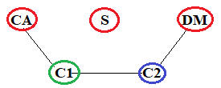
From the graph above, the vertices represent subjects, while edges connecting them show the conflicts between subjects. This means that College Algebra (CA) and Calculus 1 (C1) cannot be attended at the same time due to time conflict. The same applies to other subjects that are interconnected with an edge. It is assumed that none of the subjects interconnected have prerequisite requirements between subjects. For instance, a student is at liberty to attend College Algebra (CA) without taking Calculus 1 (C1) beforehand. Possible reasons for schedule conflict could be having one professor assigned to teach two subjects, let us say, College Algebra (CA) and Calculus 1 (C1). However, there are no conflicts between College Algebra (CA), Statistics (S), and Discrete Mathematics (DM). According to Levin (2021), the smallest number of colors needed to get a proper vertex coloring is called the chromatic number of the graph. In this case, the chromatic number for this case is 3, where red color will be applied to College Algebra (CA), Statistics (S), and Discrete Mathematics (DM), blue color to Calculus 2 (C2), and finally green color to Calculus 1 (C1). Therefore, it can be interpreted that at least 3 time slots are needed to schedule all sessions without conflicts.
- Explain Euler and Hamiltonian cycles and provide one simple counter example for each.
Levin (2021) defines Euler path as a walk through the graph which uses every edge exactly once. A theorem on Euler circuits and Euler paths states that a finite connected graph has a Euler circuit if and only if each vertex has even degree and a finite connected graph has a Euler path if and only if it has most two vertices with odd degree (Jamaloodeen et al., 2021). A triangle with 3 vertices and 3 edges can be used a simple graph to demonstrates a counter example for a Euler path. Based on the theorem stated above, a square would not be considered to have a Eulerian path due to not all its vertices connected, despite all of them having an even degree (they all have degree 2). In other words, there is no path that visits all edges exactly once and ends at the starting vertex, thus the graph is not traversable in a single path.
On the other hand, a Hamiltonian cycle is one where every vertex, except for the starting and ending vertex, is visited exactly once (Jamaloodeen et al., 2021). Theorem (Dirac) on Hamiltonian graphs states that a simple graph, with $n≥3$ vertices, is Hamiltonian if every vertex (v) has degree $d(v)≥\frac{n}{2}$ (Jamaloodeen et al., 2021). Using a square with four vertices labeled as W,X,Y and Z to give a counter example for a Hamiltonian cycle, the theorem requires that we would need to pass through each vertex exactly once and return to the starting vertex. If we do so by commencing from the vertex W, a Hamiltonian cycle would require passing through X, Y and to Z to complete the cycle. Since X and Z are connected, it means that it would be impossible for a square graph to form a Hamiltonian cycle in this square graph.

Find the Euler circuit/path and Hamiltonian cycle/path for the given graph G.
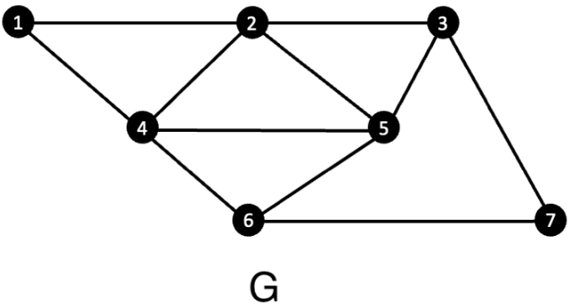
Examining the undirected graph G, we can observe the following:
Vertex set: $V=\{1,2,3,4,5,6,7\}$
Edge set: $E=\{\{1,4\},\{1,2\},\{2,4\}\{2,5\},\{2,3\},\{3,5\},\{3,7\},\{7,6\},\{5,6\},\{5,4\}\{4,6\}\}$
Vertex degree: $D(1)=2, D(2)=4, D(3)=3, D(4)=4, D(5)=4, D(6)=3, D(7)=2.$
Since the degree of vertex 3 is odd, it therefore follows that graph G is has neither Euler circuit/path nor Hamiltonian cycle/path, which makes it impossible to visit all edges exactly once and ends at the starting vertex despite having all the vertices connected to each other.
- Explain the spanning tree. Find at least two possible spanning trees for the following graph H and explain how you determined that they are spanning trees. Draw a bipartite graph from any one of the two spanning trees that you found.
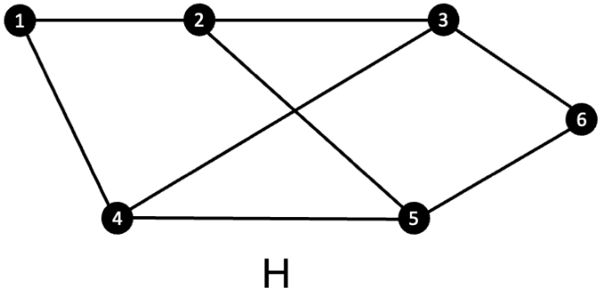
Given a connected graph ,G, Jamaloodeen et al. (2021) states that a spanning tree of G is a subgraph of G which is a tree and includes all the vertices of G. They concluded every connected graph has a spanning tree.
Spanning tree 1:
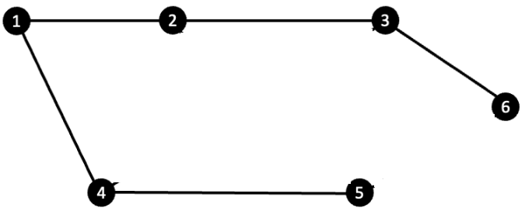
Explanation:
I started with vertex 1 then included the edges {1, 2}, {1, 4}, {2, 3}, {3, 6}, and {4, 5}, all of which are connected to vertex 1 and ensured all of them are connected provided there is no cycle created.
Spanning tree 2:
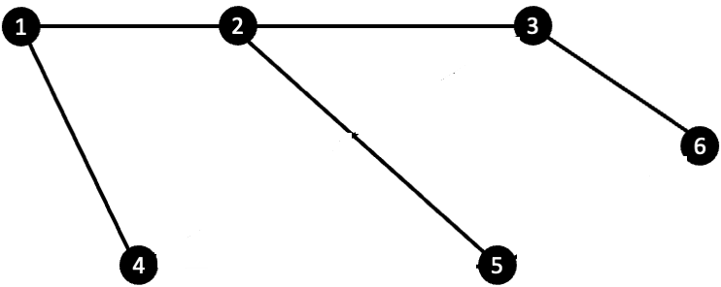
Explanation:
I started with vertex 2 then included the edges {2, 1}, {2, 3}, {2, 5}, {3, 6}, and {1, 4} by ensuring there is no cycle created.
Bipartite Graph
Levin (2021) defines a bipartite graph as one for which it is possible to divide the vertices into two disjoint sets such that there are no edges between any two vertices in the same set. Below is a $K_{3,3}$ bipartite graph from spanning tree 1.
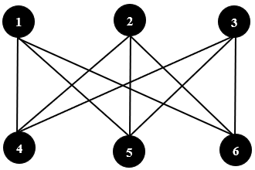

References
Jamaloodeen, M., Pinzon, K., Pragel, D., Roberts, J., & Siva, S. (2021). Discrete Math (3rd ed.). licensed under CC BY-NC
Levin, O. (2021). Discrete mathematics: An open introduction (3rd ed.). licensed under CC 4.0

